Suggestion for SENCo Forum Training
- Slide 1: Introduction
- Introduction of EP and topic of presentation.
- Brief explanation of what will be covered in the presentation:
- Managing social, emotional, and mental health challenges in pupils, particularly when they manifest as challenging behaviour.
- The importance of considering the function of presenting behaviours and the needs of pupils when managing challenging behaviour.
- introducing the theory of Affect script and explanation of how pupils' biographies can intensify their reactions to situations.
- Strategies for supporting pupils, both individually and as a whole school.

- Slide 2: Understanding challenging behaviour
- What do we understand by challenging behaviour?
- Challenging behaviour can be defined as any behaviour that interferes with a pupil's learning or the learning of others.
- It can include things like aggression, defiance, withdrawal, and self-injury.
- it's important to recognise that challenging behaviour can be a manifestation of underlying social, emotional, and mental health challenges.
- As educators, it's our responsibility to understand the function of presenting behaviours, so we can identify the needs of the pupils who are exhibiting them.

- Slide 3: The function of presenting behaviours and assessment tools
- Presenting behaviours may not always conform to school norms, but they may serve to minimise negative affects triggered by persistent challenges.
- Educators can use several tools and resources to assess the function of presenting behaviours. These resources can help to identify the underlying needs of pupils and inform the development of targeted support strategies, examples include:
- Functional behaviour assessments.
- Observations, interviews, and checklists.
- [if time permits, include an interactive activity of some case studies of pupils exhibiting challenging behaviour and ask the SENCOs to work in groups to identify the underlying function of the behaviour and suggest assessment tools that could be used to gather more information].

- Slide 4: Theory of affect script and affects under positive, neutral, and negative
- Silvan Tomkins' [Ref] theory of affect script:
- According to Tomkins, we all have 9 innate affects that are hard-wired into our autonomic nervous system from birth. We have no control over them, and they are triggered by stimulus in our environment and/or our thoughts.
- Central Executive: Tomkins posits that human individuals are programmed to:
- Maximise positive affect.
- Minimise negative affect.
- Minimise the inhibition of affect.

- The different affects under positive, neutral, and negative include:
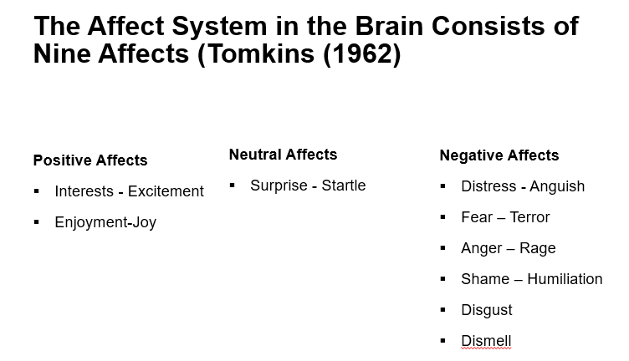

- Examples of what might trigger these affects include:
- Pupil’s senses picking up something to big, too loud, or too fast, and/or feeling threatened (fear-terror).
- Response triggered when too much has been happening for too long, or when overwhelmed (distress-anguish).
- When that too much finally stops happening or a reward is received (enjoyment-joy).
- When senses encounter a novel stimulus that is just right or discovering something new (interest-excitement).
- Experiencing an unexpected event (surprise-startle).
- Being treated unfairly (anger-rage).
- Encountering something unpleasant (disgust).
- Feeling exposed (shame-humiliation).
- [if time permits, include an interactive activity where the SENCOs work in groups to identify examples of triggers for each of the different affects, and share them with the group].

- Slide 5: The role of biography – looking beyond presenting behaviour
- A pupil's biography can intensify their reactions to situations. This is particularly true when pupils are confronted with challenges that have persisted for a long time.
- Pupils may use presenting behaviours as a way to maximise positive affects and avoid negative affects triggered by persistent challenges. For example, a pupil who has experienced neglect may seek attention through disruptive behaviour, as a way of compensating for the lack of attention they received at home.
- By understanding the role of biography, we can begin to recognise the underlying needs of pupils and respond to them in a more targeted way.
- Most of the experiences of interest and joy that get impeded have to do with interpersonal engagement with others. So, think of shame as an interpersonal/interactional affect.
- Once positive affect is impeded, the affect shame focuses attention on the impediment that triggered the negative affect.
- Now, the thing is what we see in the moment of shame is something in us that isn’t perfect – scripted emotions/biography.
- Pupil’s draw on scripts built up over time to help minimise the destructive impact of negative affects…

- Slide 6: The compass of shame poles and scripts
- The compass of shame is a useful tool for understanding the default scripts that pupils draw on when a negative affect is triggered.

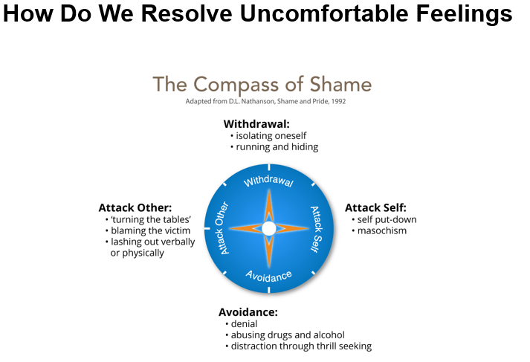

- The four poles of the compass of shame are:
- Withdrawal (the pupil retreats into themselves, switch off from learning and not attend lessons).
- Avoidance (the pupil avoids the situation altogether, be the class clown, focus on other aspect of their lives, take risks, use drugs etc.).
- Attack others (the pupil blames others, put others down, belittle value of work, diminish and bully others etc.).
- Attack self (the pupil blames themselves, put themselves down, they assume they are dumb etc.).
- When pupils feel shame, they may draw on these scripts as a way of protecting themselves from further harm.
- As educators, it's important to recognise the power imbalances that exist between staff and pupils and work to create a safe and trusting environment where pupils feel comfortable expressing their underlying struggles.
- [if time permits, include an interactive activity where the SENCOs reflect on a time when they experienced shame and identify which pole of the compass they defaulted to. They can share their experiences with the group and discuss how they could use this understanding to support pupils who are experiencing shame].

- Slide 7: Supporting pupils and practical advice handout
- If time allows, this should be an interactive activity:
- Ask the SENCOs to work in groups to brainstorm practical strategies for supporting pupils with social, emotional, and mental health challenges. They could then share their ideas with the group.

- Provide feedback and share additional suggestions:
- There are many strategies for supporting pupils with social, emotional, and mental health challenges.
- Individually, strategies such as counselling, mentoring and pastoral care can be effective in helping pupils to identify and manage their presenting behaviours.
- As a whole school, approaches such as positive behaviour support and restorative justice can be effective in creating a safe and supportive environment for pupils.
- In addition to these strategies, educators can use the following practical tips to manage challenging behaviours:
- Set clear expectations and boundaries for behaviour.
- Use positive reinforcement to encourage positive behaviours.
- Be consistent in your responses to behaviours.
- Use visual aids and other non-verbal communication tools to support pupils with communication difficulties.
- Use de-escalation techniques to manage situations where pupils are becoming agitated or upset.
- Work collaboratively with other professionals, such as counsellors and therapists, to provide comprehensive support to pupils.
- Provide opportunities for pupils to express their feelings and concerns in a safe and supportive environment.
- Create a risk-tolerant learning zone.
- Establish/communicate high expectations (not just high standards).
- Example of communicating high expectations: As you learn this, mistakes are expected. Your mistakes help me to support you. Let’s make mistakes together!
- Give feedback that focuses on process – things that they can control.
- Example of when they struggle despite strong effort: I admire your persistence and I appreciate your hard work. It will pay off!
- Example of when they struggle and needs help with strategies: Let’s do one together…
- Example of when they are making progress: I see you using your strategies/tools/notes etc. keep it up!
- Example of when they succeed with strong effort: I am very proud of you for not giving up and look what you have to show for it!
- Focus on how tasks/activities are framed and how feedback is provided
- Example of communicating learning goals: we are in the learning zone today; mistakes are our friends!

- These practical tips can be used as a takeaway handout or list of suggestions for educators to refer to when managing challenging behaviours.

- Slide 8: Conclusion
- In conclusion:
- Managing challenging behaviour requires us to consider the function of presenting behaviours and the needs of pupils who are exhibiting them.
- By understanding the theory of affect script, the role of biography, and the compass of shame, we can begin to recognise the underlying needs of pupils and respond to them in a more targeted way.
- Using assessment tools and resources, educators can identify the underlying needs of pupils and develop targeted support strategies.
- Through using practical tips, educators can manage challenging behaviours and support pupils to achieve positive outcomes.

Thank you for listening, and I hope you find these insights and strategies useful in your work with pupils.

Q&A session at the end of the presentation to allow SENCOs to ask questions and share their own experiences and strategies for managing challenging behaviour. This could be a valuable opportunity for sharing best practices and collaborating with others in the field.

References

